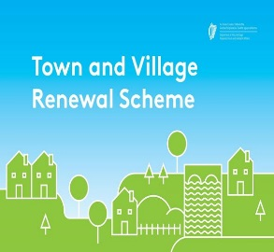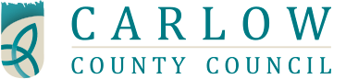

Business & Community Workshop

For the Town & Village Scheme 2017

16th May 2017 @ 7.30pm

Lord Bagenal Hotel , Leighlinbridge , County Carlow

The Town and Village Renewal Scheme is an initiative under the Government’s Action Plan for Rural Development, Realizing our Rural Potential, and is part of a package of national and local support measures to rejuvenate rural towns and villages throughout Ireland. A National Fund of €20m will be made available on a competitive basis for projects developed at local level.

Expressions of Interests are invited from communities for the scheme and in order to facilitate and support communities, Carlow County Council will host a public meeting on 16th May 2017 @ 7.30pm in the Lord Bagenal Hotel , Leighlinbridge , County Carlow.

In order to assist with the application process communities are asked to gather representatives from business and community interests to attend this meeting. The workshop will give the background to the scheme and also outline the competitive process for 2017 and give guidance for the expression of interest process. The closing date for expressions of interest from communities will be close of business on 22nd May 2017. It is essential that communities attend this workshop in order to develop project proposals suitable for evaluation for the proposed fund.

This scheme is open to rural locations in County Carlow and excludes Carlow Town.

To register for this meeting please e-mail enterprise@carlowcoco.ie or call 059/9129783

An outline of the application process and copy of the expression of interest form is available from www.carlow.ie or www.localenterprise.ie/carlow or by calling 059/9129783 or e-mailing kcomerford@carlowcoco.ie

